UNIT3
CSS Advanced (Grouping, Dimension, Display, Positioning, Floating, Align, Pseudo class, Navigation Bar, Image Sprites, Attribute sector),

Advanced CSS Topics
Grouping
- Combining selectors: Allows you to apply the same styles to multiple elements.
CSS
h1, h2, h3 {
color: blue;
}
- Nested selectors: Apply styles to elements within other elements.
CSS
div.container {
background-color: lightgray;
p {
color: red;
}
}

Explanation
CSS Grouping: Combining Selectors
Grouping in CSS allows you to apply the same styles to multiple elements at once, enhancing efficiency and code readability. This is achieved by separating the selectors with a comma (,).
Syntax
CSS
selector1, selector2, selector3 {
/* Common properties */
}
Example
CSS
h1, h2, h3 {
color: blue;
font-weight: bold;
}
In this example, the styles color: blue; and font-weight: bold; are applied to all <h1>, <h2>, and <h3> elements.
Advantages of Grouping
- Reduced code: You can write fewer lines of CSS by combining similar styles.
- Improved maintainability: If you need to change a style, you only need to modify it in one place.
- Enhanced readability: The code becomes more organized and easier to understand.
Types of Selectors in Grouping
You can group various types of selectors:
- Element selectors: p, h1, div
- Class selectors: .button, .highlight
- ID selectors: #header, #footer
- Attribute selectors: [href], [title]
- Pseudo-classes: a:hover, input:focus
Example with Different Selectors
CSS
p, .highlight, #intro {
font-size: 18px;
}
Important Considerations
- Specificity: While grouping selectors is efficient, remember that more specific selectors will override less specific ones.
- Performance: While grouping can improve performance by reducing the number of style calculations, excessive grouping might have the opposite effect. Use it judiciously.
By effectively using CSS grouping, you can write cleaner, more maintainable, and efficient stylesheets.
Additional Tips
- Consider using CSS preprocessors (like Sass or Less) for advanced grouping and nesting features.
- Group related selectors together for better organization.
- Test your styles thoroughly to ensure expected results.

Dimension
- Width and height: Control the size of an element.
CSS
div {
width: 200px;
height: 150px;
}
- Box-sizing: Determines how width and height are calculated (content-box or border-box).
CSS
div {
box-sizing: border-box;
}
- Max-width and min-width: Set maximum and minimum width for an element.
CSS
img {
max-width: 100%;
}

Display
- Controls how an element is displayed:
  - block: Displays as a block-level element (takes up full width).
  - inline: Displays as an inline element (no line break).
  - inline-block: Combines block and inline behavior.
  - flex: Enables flexible layout using flexbox.
  - grid: Enables grid-based layout.
CSS
div {
display: flex;
flex-direction: row;
}
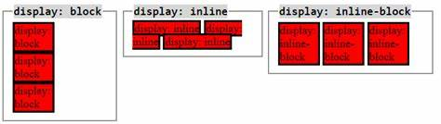

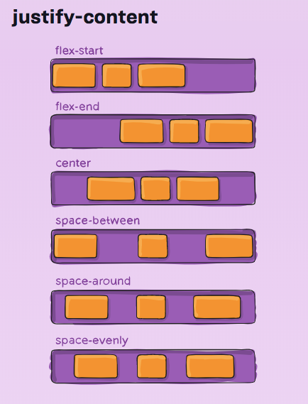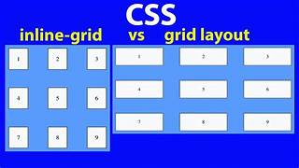

Positioning

- Controls the placement of an element:
  - static: Default, no positioning.
  - relative: Positioned relative to its normal position.
  - absolute: Positioned relative to the nearest positioned ancestor.
  - fixed: Positioned relative to the viewport.
  - sticky: Hybrid of relative and fixed.
CSS
.header {
position: fixed;
top: 0;
left: 0;
width: 100%;
}

Floating
- Takes an element out of the normal flow and places it to the left or right.
CSS
img {
float: left;
}
- Clearfix hack: Used to clear floats and prevent content from wrapping around floated elements.
Align
- Aligns content within an element:
  - text-align: Aligns text within an element.
  - vertical-align: Aligns inline elements vertically.
  - align-items: Aligns items in a flex container.
  - justify-content: Distributes space between items in a flex container.
CSS
.container {
display: flex;
justify-content: space-between;
}

Pseudo-classes
- Style elements based on their state:
  - :hover: When the mouse hovers over an element.
  - :active: When an element is being activated.
  - :focus: When an element has focus.
  - :visited: For links that have been visited.
CSS
a:hover {
color: red;
}
Detail Explanation

CSS Pseudo-Classes: Styling Based on State
Pseudo-classes allow you to style an element based on its current state or condition. They are preceded by a colon (:) in CSS.

Example: Styling a Link with Pseudo-Classes

HTML
<a href="https://example.com">Visit Example</a>
CSS
a {
color: blue;
text-decoration: none;
}

a:hover {
color: red;
text-decoration: underline;
}

a:active {
color: green;
}

a:visited {
color: purple;
}

a:focus {
outline: 2px solid blue;
}
Explanation
- a: Styles all anchor elements (links).
- a:hover: Styles the link when the mouse hovers over it.
- a:active: Styles the link while it's being clicked (activated).
- a:visited: Styles links that have already been visited.
- a:focus: Styles the link when it has focus (usually when tabbed to).
Other Common Pseudo-Classes
- :first-child: Applies styles to the first child element of a parent.
- :last-child: Applies styles to the last child element of a parent.
- :nth-child(n): Applies styles to the nth child element of a parent.
- :empty: Applies styles to elements with no content.
- :enabled: Applies styles to enabled form elements.
- :disabled: Applies styles to disabled form elements.

Example with Multiple Pseudo-Classes
CSS
button {
background-color: blue;
color: white;
padding: 10px 20px;
border: none;
cursor: pointer;
}

button:hover {
background-color: darkblue;
}

button:active {
background-color: black;
}

button:focus {
outline: 2px solid yellow;
}
This example styles a button with different states: normal, hover, active, and focus.
Key Points
- Pseudo-classes enhance user interaction and experience.
- They can be combined with other selectors for more specific styling.
- Use them judiciously to avoid overly complex stylesheets.
By effectively using pseudo-classes, you can create dynamic and interactive elements on your web pages.
Example
Objective:
To enhance the visual appearance and user experience of links on a webpage by applying different styles based on their state (normal, hover, active, visited, focus).
HTML Structure:
HTML
<!DOCTYPE html>
<html>
<head>
<title>Pseudo-Class Example</title>
<link rel="stylesheet" href="styles.css">
</head>
<body>
<a href="https://www.example.com">Visit Example</a>
</body>
</html>
CSS (styles.css):
CSS
a {
color: blue;
text-decoration: none;
}

a:hover {
color: red;
text-decoration: underline;
}

a:active {
color: green;
}

a:visited {
color: purple;
}

a:focus {
outline: 2px solid blue;
}
Explanation:
- HTML Structure:
  - Creates a basic HTML structure with a link element.
  - Links the external stylesheet "styles.css".
- CSS Styling:
  - a: Applies default styles to all anchor elements (links). Sets the color to blue and removes the default underline.
  - a:hover: Styles the link when the mouse hovers over it. Changes the color to red and adds an underline.
  - a:active: Styles the link while it's being clicked (activated). Changes the color to green.
  - a:visited: Styles links that have already been visited. Changes the color to purple.
  - a:focus: Styles the link when it has focus (usually when tabbed to). Adds a blue outline.
By incorporating this CSS into your HTML, you will create links with enhanced visual feedback for users, improving the overall user experience.
Additional Notes:
- You can apply these pseudo-classes to other elements besides links, such as buttons.
- Consider using more specific selectors (e.g., .button:hover) for better control over styles.
- Always test your styles across different browsers to ensure consistent behavior.
By understanding and utilizing pseudo-classes, you can create dynamic and interactive web pages that respond to user interactions.

Navigation Bar

- Creating a horizontal or vertical menu:
  - Use unordered lists (ul) and list items (li).
  - Apply styles for spacing, color, and hover effects.
  - Consider using flexbox or grid for layout.
CSS
nav ul {
list-style: none;
display: flex;
}

Image Sprites
- Combining multiple images into a single image:
  - Improves performance by reducing HTTP requests.
  - Use background-image and background-position to display different parts of the image.

CSS
.icon {
background-image: url('sprites.png');
background-repeat: no-repeat;
}
.icon-home {
background-position: 0 0;
}

Attribute Selector
- Selects elements based on their attributes:
  - [attribute] selects elements with a specific attribute.
  - [attribute="value"] selects elements with a specific attribute value.
CSS
a[target="_blank"] {
color: blue;
}

